**Assignment no 3**

1)

#include<iostream>

using namespace std;

class area

{

float r, temp;

public:

inline void read();

inline void compute();

inline void display();

};

void area ::read()

{

cout<<"enter the radius:";

cin>>r;

}

void area ::compute()

{

temp= 3.14*r*r;

}

void area ::display()

{

cout<<"\n area of the circle:"<<temp;

}

int main()

{

area a;

a.read();

a.compute();

a.display();

}

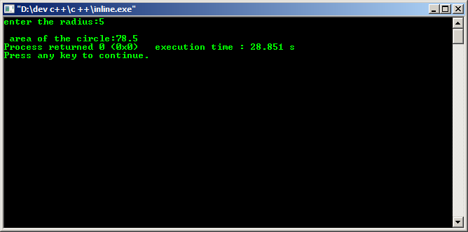

2)